

Electronic Project

ELX2

Submitted by:

Fionnbharr Jones - R00127776

Kevin Histon - R00130665

Dean Devereaux - R00116198   
 Liam O’ Donovan - R00121155

Supervisor & Assessor:

Gary Dwyer & Michael Murray

Department of Electrical & Electronic Engineering

# Table of Contents

Contents

Table of Contents 2

Abstract 3

1. Introduction 4

2. Circuit Choice 4

3. Proteus 5

3.1. ISIS 5

3.2. ARES 6

4. Construction 7

5. Results 8

5.1. Light Sensitive Switch 8

5.2. Baby monitor 8

5.3. Infrared Receiver 9

5.4. Thermistor 9

6. Individual Account 10

6.1. Dean 10

6.2. Fionnbharr 12

6.3. Kevin 13

6.4. Liam 15

7. Conclusion 17

8. Bill of Material 18

Appendices 20

# Abstract

The project at hand consists of a light sensitive switch, a thermistor circuit, a baby monitor circuit and an IR receiver completed by Dean, Kevin, Liam and Fionnbharr respectively.

Each of the circuits have been designed to give 0-5 volts varying outputs so a PIC or an Arduino could measure the environment it is in using sound, light, temperature and receiving infrared. We used the same op amp for the three circuits in two cases. The LDR and the thermistor have the same circuit layout and configuration of a differential op amp, and the third op amp is set as differentiator op amp for the IR receiver.

The circuit that has no op amps is the baby monitor, reading in sound, this uses an array of transistors to amplify mechanical vibrations and convert them to electrical signals. All the designing and simulations were carried out on proteus design suite. This application also generated the bill of materials for our project.

We constructed the circuit according to the design that we devised. The workshop was used properly to construct the circuit on the PCB and solder the components onto the board. All four circuits were tested in this workshop with the equipment available.

# Introduction

Starting this module on the first day of semester an outline of what would be expected of us was the main topic. We were told that through the next 13 weeks we’d need to work on a circuit which uses a sensor and can operate on a voltage of 0-5V, the plan for the semester was created and went as follows:

1. **ISIS Circuit Schematic**  - Week 4
2. **ARES Circuit Schematic** - Week 6
3. **Presentation** - Week 6
   1. *Plan*
   2. *B.O.M.*
   3. *ISIS Design*
4. **Construction** - Week 9
5. **Project Report** - Week 11
   1. *Plan*
   2. *B.O.M.*
   3. *Logbook*

# Circuit Choice

To find a Circuit that would be level with our understanding of electronics we used the website [www.velleman.com](http://www.velleman.com) and choose an individual circuit with a sensor component, All circuits except the thermistor were found in minikits category on velamen.

The thermistor was found on the website [http://www.next.gr/circuits/ind](http://www.next.gr/circuits/index761.htm).

Once a circuit was chosen the schematic was downloaded from the site and used as a template to be altered for our final circuit.

# Proteus

# ISIS

The circuits from velleman were set up on ISIS individually by each group member, this was worked on through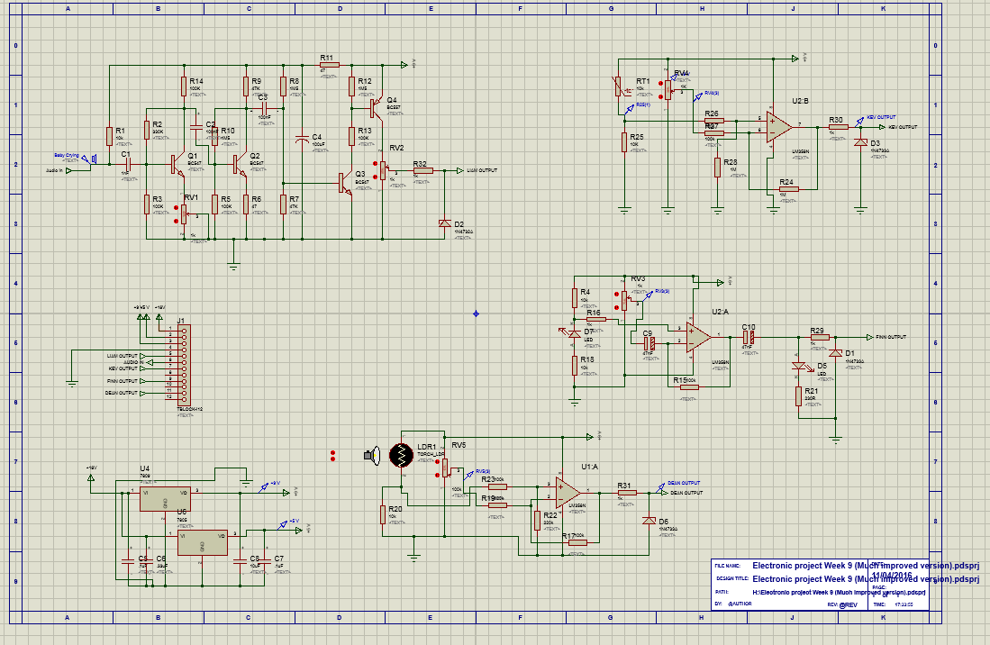weeks two to seven, all circuits were altered in many ways. It was only in week five that we started coming together as a team when all our circuits were simulating without errors and placed on the same schematic Two power supply rails were added to the plan. 5V and 9V, which can be seen on the bottom left of the figure above. A terminal block was also added to our schematic for inputs, outputs, and ground. Our goal was to complete ISIS in week four, we finalized it in week seven.

# ARES

Once ISIS was complete, we could use the schematic and created a circuit layout for a PCB on ARES. Unfortunately, we never checked a few components for packages on ARES so this had to be dealt with before placing the circuit layout down. The components were placed as such, a circuit and all its components would be placed together and a route for wires would be automatically done, when the first circuit's wires were all connected without problems, we would move onto the next and so on. Shared components were placed into the middle of the board, this layout worked for majority of components, but some still were not connected. To get over this top copper wiring was used twice. The board itself was to be less than 15 cm in length and width, we finalized ARES in Week 9.

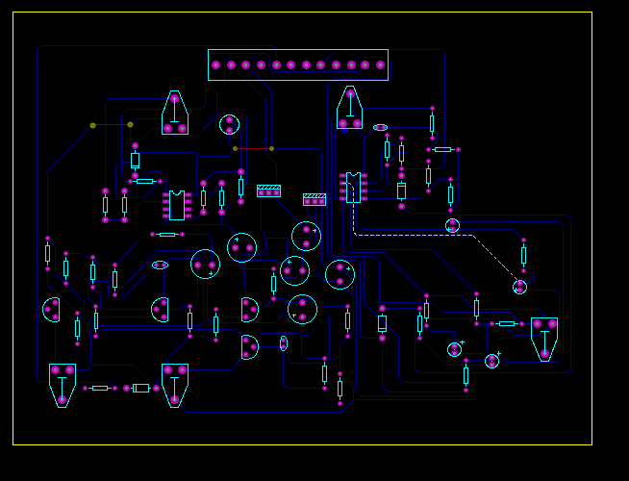

# Construction

Physical work was started in week ten. Making sure our ARES was finalized we sent our lecture an email of the circuit where he then printed it off on a transparent sheet.

Upon our handling of the sheet while waiting to produce the board some lines were scratched; this could result in a break in wiring and disable the circuit from working.

The transparent sheet was put into a UV light box with a sensitive PCB. making sure the PCB and sheet were correctly placed the PCB would then be exposed to the Light for 2 minutes. Once complete an ink pen was used to mark the break in wiring and straight away the chemical process was to begin without exposing the board to any light.

There were four steps in this process

1. Sodium Hydroxide - 1 minute
2. Ferric Chloride - 5 minutes
3. Photoresist Stripping Solution - 5 minutes
4. Tin Plating Solution - 12 minutes

Once this is complete the board must be cleaned and holes for components can be drilled. The majority of components such as resistors needed a 0.8mm hole and the terminal block needed 1mm. Drilling took about 20 minutes to complete, a track was damaged while drilling the terminal.

The final step was soldering the components onto the board. We started with the small components first and made our way to the bigger ones. A great tip but was only discovered halfway through our soldering was to cut off the long wire legs before soldering as the legs steal all the heat and the solder climbs the leg instead of filling the hole. The damaged track on the terminal was fixed by placing a wire and soldering both ends to the board, this was also done for broken tracks found.

Soldering of components was completed week 11 and testing could start in the final week.

# Results

On week 12 our Circuit was fully complete and ready for testing, we used a DC power supply, Multimeter, Oscilloscope, Signal Generator and an Infrared Transceiver via Mobile Phone to verify the operation of the circuits

# Light Sensitive Switch

This was the first section of the board that we tested. We needed to locate the 12V, 9V, 5V and ground. There was a small break which was found with the help of our supervisor Gary Dwyer using the multimeter to check for continuity on the track. Once this was repaired the LDR worked perfectly we were able to scale the voltage to 0 with the pot and LDR covered and watched the voltage vary on the output as we increased and decreased the light to the LDR. After the test had been carried out a problem came to our attention. There was a loose connection from where the board had to be repair previously. From a slip during the drilling out the bored this had cut out a section of track. The track was repair with a bit of wire but did not make a great connection so need to be solder later again.

# Baby monitor

Each individual circuit was tested on Proteus using Isis. This was used to try to iron out all our potential problems. But in the case of the baby monitor all the readings from the input to the output were as expected. But unfortunately, under real-world conditions rather than amplifying, the signal was attenuated at each stage. For the testing of the baby monitor we use the function generator, digital multimeter and an oscilloscope. With the help of supervisor Michael Murray, we divided the board into sections. Then with the function generator started off at 1 kHz and went up to 10 kHz at each section we would measure the output of the transistor. using the oscilloscope only to find the signal attenuating rather than amplifying. our conclusion was that the resistor values of the bipolar transistor’s arrangement were too small. But if values were replaced, we believe that the board would work perfectly.

# Infrared Receiver

In the case of the infrared receiver we used the DC power supply and Multimeter. We were unable to determine whether the device being using for producing an infrared signal was working or if the infrared receiver was working. When testing this circuit, we came to the conclusion that one of the capacitors was wrongly placed. It was on the varying DC voltage line the DC voltage would not pass true the capacitor. On the advice of our supervisor Michael Murray we would bypass the capacitor by short circuit. This did allow the DC voltage through and we could vary the voltage to the amplifier from the pot. There was a break in the track that needed to be solder with a bit of wire. We believe that this board could be working and if it’s not that it just requires a new infrared receiver. We were unsuccessful in our attempts to get this circuit operating.

# Thermistor

For testing the thermistor circuit, DC power supply and Multimeter were used. This circuit had to be tested using a LDR as a thermistor. A thermistor was ordered but had not yet arrived, for testing purposes we used a 10K LDR in place of the thermistor. There were two breaks in the track these were found by using the multimeter and setting it to continuity. When there was no continuity on the track this meant there was a break. Between these two points so we would need to narrow it down to find the bricks. Which we did and we repaired the track by soldering wire over the track. Once this was repaired the LDR worked perfectly with the pot we were able to scale the voltage to 0 with the LDR covered and watched the voltage very on the output as we increased and decreased light to the LDR.

# Individual Account

# Dean

The circuit I chose was the **light sensitive switch.** This circuit appealed to me as I could use the skills I learned for future projects.

Figure (D1) is of the schematics taken from velleman for my circuit. The project was created on Proteus.

*Figure D SEQ Figure_D \* ARABIC 1*

**Week 3:**

ISIS design took a lot of work as my simulation was giving errors. I ended up having to alter the circuit. Therelay,switch and transistor was removed from the output of the circuit. It was suggested by group member Kevin that the Amp may be wired up to be a **differential amplifier**.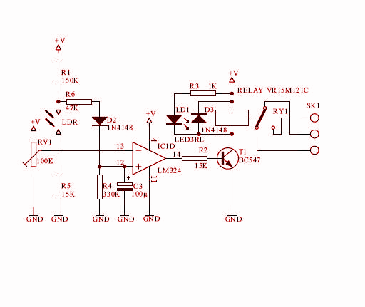

**Week 4**: I was still working on ISIS. A resistor was added in between the POT and op-ampand I removed the diode, resistor R1, resistor R4 and the capacitor. The circuit now simulated without errors, but I still needed to learn how it worked.We were also requested to use a zener diode so the output did not exceed 5 volts.

**Week 5:** Our group created a B.O.M. list for all circuits and sent this to our supervisor who would then acquire the components from our department and online. At this time all our circuits were complete and we could now place the same schematic. Figure (D2) shows my altered circuit finalized.

**Week 6**: Our presentation was scheduled for this week. Power point presentation was set up on Google documents by Fionnbharr. This allowed us as a group to alter one presentation at the same time. Our presentation was successful. Constructive criticism commented on our background being too plain and our group was praised for our Facebook group chat in which we use to communicate about the project.

**Week 7:** ISIS was finalized, and ARES was started. Every component needed a package assigned and circuits looked through thoroughly to make sure there was no mistakes. Our supervisor requested we print a B.O.M. from Proteus so he may retrieve components from our department. As a team we set up jobs for each other, Kevin and I set up all the circuits on ARES.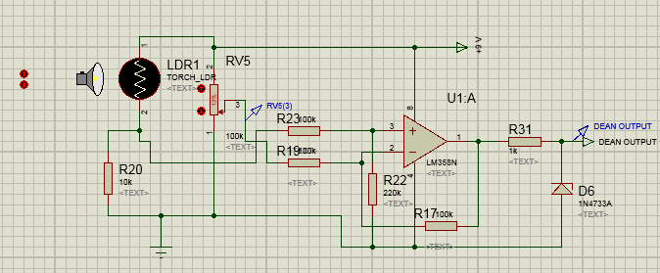

*Figure D SEQ Figure_D \* ARABIC 2*

**Week 8**: This was after the Easter holidays. I had to account for the components we received in week seven. Kevin and I worked further on ARES. We fixed some errors. It was revealed that the physical board must be smaller than half an A4 page and also that **top coppers** could be used if one or two wires were missing.

**Week 10:** We started to build our board. One member from each group worked on the chemical processes of the board so as not cramp up the workshop. I took the role of looking after the PCB. After twenty minutes the PCB was ready to be drilled and components soldered.

The Wednesday of this week I soldered the majority of components so we would have more time in the last two weeks.

**Week 11:** All that was left was polarized and ordered components. I noticed that some capacitors were not physically present and a 1k resistor used was mistaken for a 10k. Kevin soldered most of the board this week. I helped to get the components ready.

**Week 12:** We waited for the ordered components but unfortunately, we only obtained a **LDR** and **infrared receiver**. We tested our board, and took note of any faults.

# Fionnbharr

My design started out as an IR transceiver circuit (see figure F1) from

<http://circuitdigest.com/electronic-circuits/ir-sensor-circuit-diagram>.

I dropped the idea of the transmitter because I could use an alternate source to light the LED as it was only an IR LED wired into the circuit. So I was now making an IR receiver, the circuit runs on 9 Volts. It is using a differential op amp, the Zener diode is there to limit the current being fed into the amp, as the infrared light hits the IR receiver the voltage increases. The POT is there to vary the voltage going into the op amp.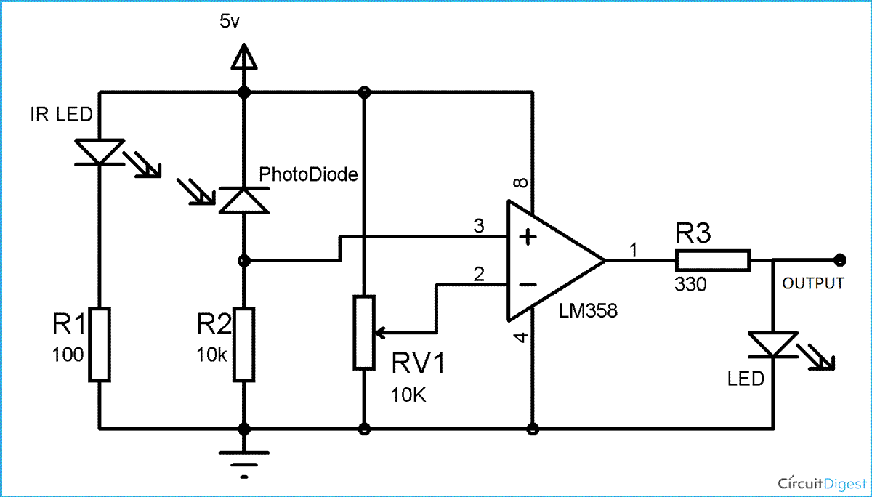

*Figure F SEQ Figure_F \* ARABIC 1*

My original idea was to do an IR transmitter that could transmit 15 different signals, but this was not allowed due to time restraints and complexity. I chose this project because I was thinking of something we use every day, and the remote control for the T.V came into mind and i was interested in how it worked.

For the second week i came up with a particular design of the transceiver, i attempted to make this work but due to time restraints i couldn't and had to change it around to the IR receiver.

While i was trying to get it the circuit to work, i asked kevin what's wrong with it and he suggested i change the amplifier from a integral op amp to a differential op amp.

With this i got readings from probes on isis to tell me that this worked,

When it came to construction, i didn’t have the IR LED until the very end so it got very little testing. In the end it didn’t work due to the infrared receiver being faulty.

# Kevin

My original project started out as a thermistor comparator circuit from [http://www.next.gr/circuits/ind](http://www.next.gr/circuits/index761.htm)

[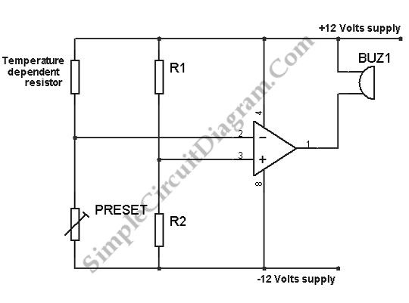](http://www.next.gr/circuits/index761.htm)

*Figure K 1*

As in Figure(K1) this circuit would not be suitable for the specification that I had been given. This was that the voltage would be varying from 5V to 0V i.e. (1V,1.57V,3V and so on) on the output but with the comparator its voltage would be either 5V or 0V with nothing in between. A new plan had to be drawn up. After many different variations and attempts, finally the differential amplifier configuration figure (K2) ticked all the boxes.

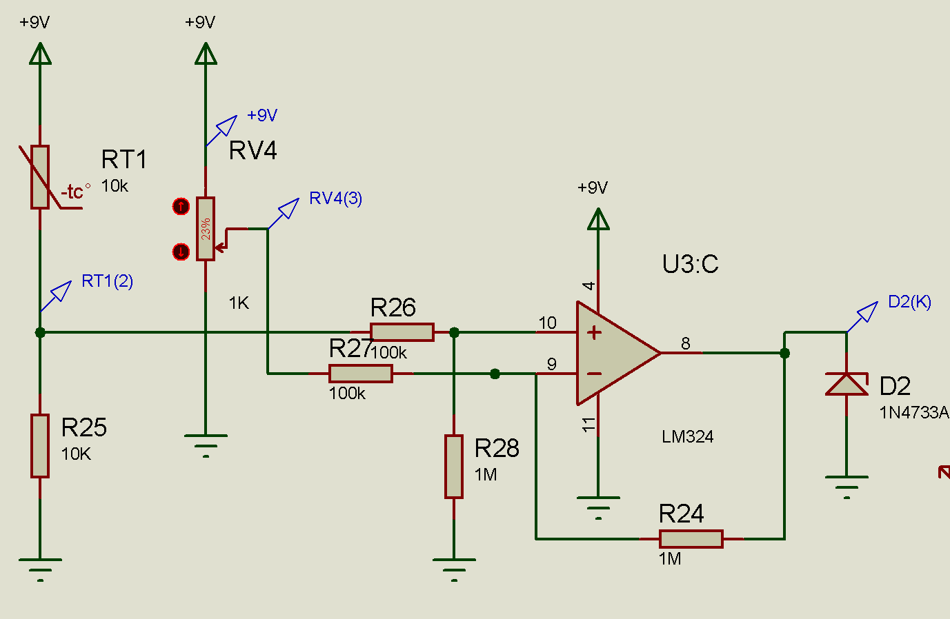

*Figure K 2*

The first three weeks were spent on working through this.

But my project was far from complete, a variable resistor (Pot) was put into the circuit to give VF voltage reference this would allow scaling of the voltage output to 0V.

The voltage rail to the op amp was set at 5V which gave a voltage less than 5V on the output so the voltage rail to the op amp was increased to 9V this in turn gave an output voltage greater than 5V. A 5V limiting circuit Figure (K3) was in place on the output which consisted of a current limiting resistor in series with a 5V Zener diode. This stabilized the output voltage and any voltage greater than 5V (the breakdown voltage) now simply would not show on the output but across the Zener diode.

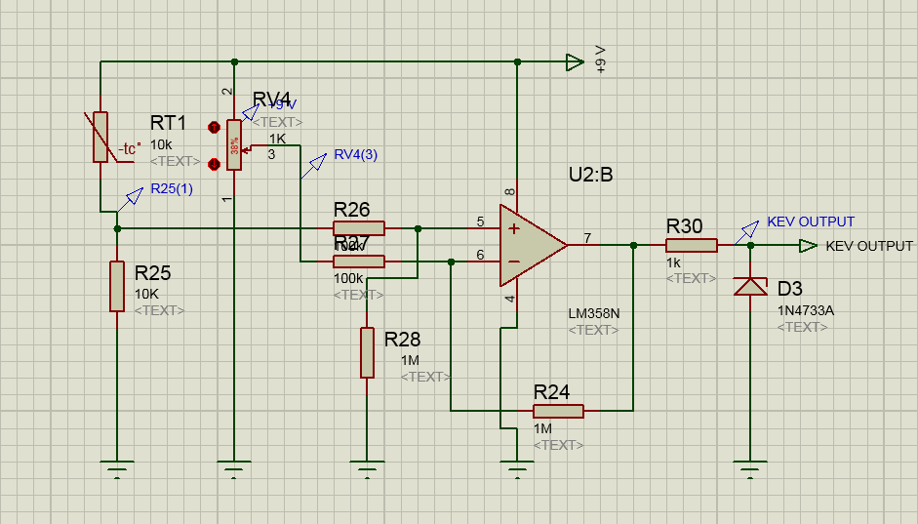

*Figure K 3*

It is at this point week 7 my individual part of the project started to come to a close. Figure (K4) shows my end design as it was when it was added to the group board. 

*Figure K 4*

# Liam

Initially I had no idea what sort of circuit I wanted to make, until we began research on [www.Velleman.com](http://www.velleman.com). I found all sorts of ideas online, but the only one that stood out was the Sound to Light circuit. Instead of copying the circuit online, I wanted to add my own twist to the circuit.  
Background: My aunt is hearing-impaired and after recently having her first child, she found it difficult to hear the Baby Monitor they had bought, despite there being an LED display on the monitor as well. It got me thinking and I fumbled onto the idea of using a motor to alert my hearing-impaired aunt that their baby was crying.   
This was only an idea and wouldn’t be a user-friendly product, but by altering the

Sound -> Light circuit, theoretically the sound picked up by a microphone should be able to power a vibrating motor.  
I researched vibrating motors, and found gaming controllers use them a lot, so I acquired a motor easily. You can see the motor weighted to one side to allow it to vibrate below.

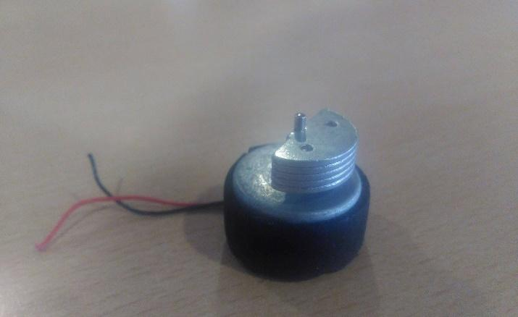

*Figure L 1*

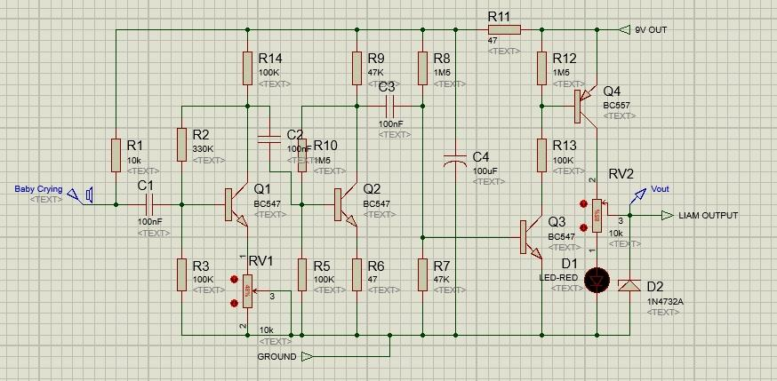

*Figure L 2*

Above, is my finalized Baby Monitor Circuit. It is almost identical to the Velleman Sound to Light circuit, despite small changes. This circuit is a Pulse Width Modulator that powers the vibrating motor.   
The Potentiometer (RV1) on the bottom left of the circuit was one of the biggest changes and was found through a lot of trial and error. This Potentiometer controls the sensitivity of the microphone and stops quiet noises turning on the motor. It almost works like a filter and I was very happy to stumble across this feature through many failed attempts.  
I also added an output regulator and voltage variation potentiometer.  
The Potentiometer (RV2) on the right of the circuit is there to allow the pulse to be between 0V and 5V. The diode (D2) stops the output from going over 5V to protect the Motor.  
Overall, I am very happy with the work I have done to my circuit, and hope to apply these findings to maybe making a User-Friendly Hearing-Impaired Baby Monitor in the future.

# Conclusion

Only half the board was operational in the end, this was unfortunate. Simulations in ISIS all worked but this was not the case for the real world.

Soldering on most of the board was not the best but we have improved in our techniques. We had a lot of broken tracks were found, if we handled the transparent sheet with more care this could have been avoided.

Between the whole process of testing we found four breaks, the one found before the acid process were fixed with a special ink pen, while the ones after were fixed by solder and wire. We now have a better understanding for problem solving when dealing with a circuits faults.

Another problem was communication in the group, even though we had a Facebook group chat, it was hard to find info on each other's circuits when dealing with ISIS and ARES and planning the process through the weeks of creating the final board.

After completing this project, we have a stronger understanding of ISIS and ARES, and we would feel a lot more confident doing the project again if we got the chance.

Overall, we enjoyed working together on such a complex project. It allowed us to use skills we had before this semester and allowed us to learn new skills. This project has helped us prepare for projects in the future, and we feel we benefited tremendously from this module.

# Bill of Material

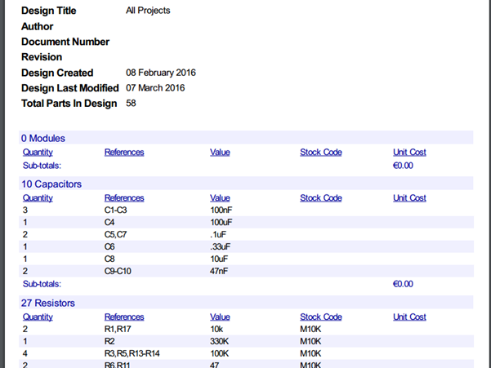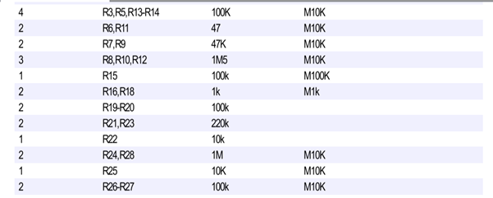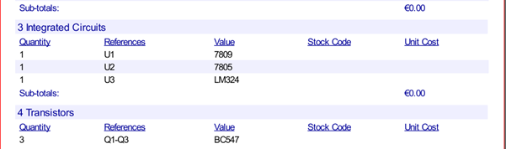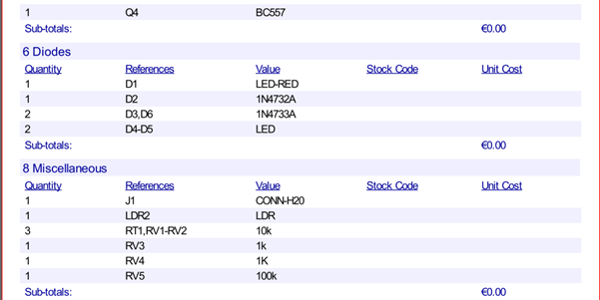

# Appendices

*Figure SEQ Figure \* ARABIC 2*

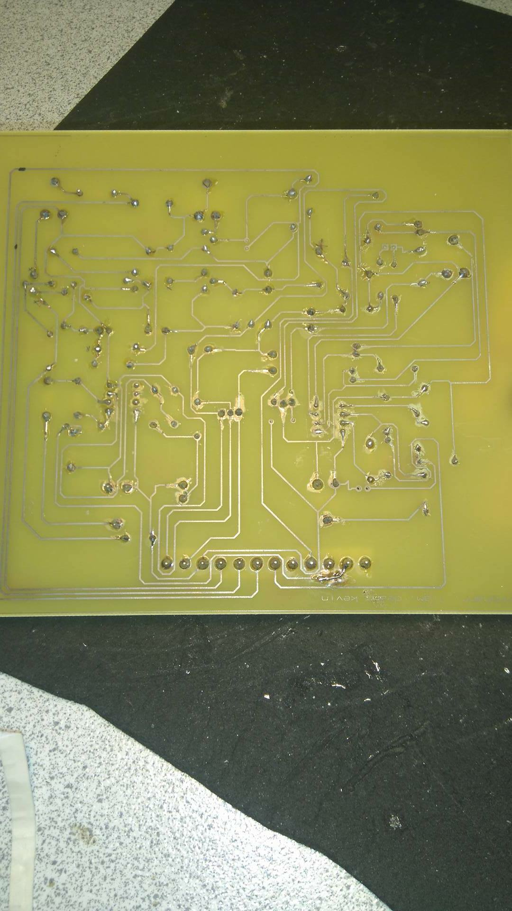

*Figure SEQ Figure \* ARABIC 3*

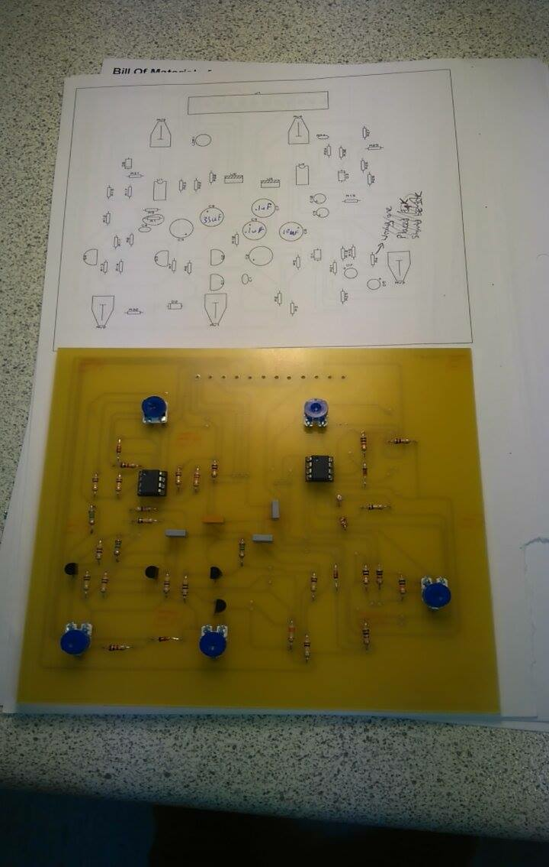*Figure 4*